**April 10, 2025**

**Subject: Bid No. 4065.14, Ceramic Supplies**

This is Amendment Number **2**

In accordance with the terms of the above-mentioned contract, this is authorization to extend this contract, through March 31, 2025. All terms and conditions remain the same.

**Supplier(s):**

**Clayworks Supplies, Inc.**

**DGS Educational Products**

**School Specialty, Inc.**

**COMMENTS**: Please see the summary of contracts.

**REFER QUESTIONS TO:** Tammy Lyles – [Tammy_M_Jarman@mcpsmd.org](mailto:Tammy_M_Jarman@mcpsmd.org)

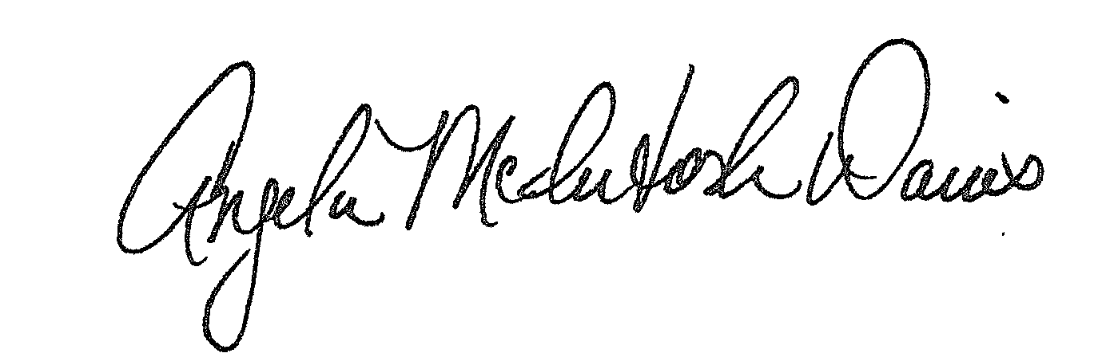

Approved:

Angela McIntosh-Davis, Director, Division of Procurement

AMD:se

Distribution: Supplier(s); Bid File